Microsoft Excel makes it easy to calculate the Rise & Fall without making any errors
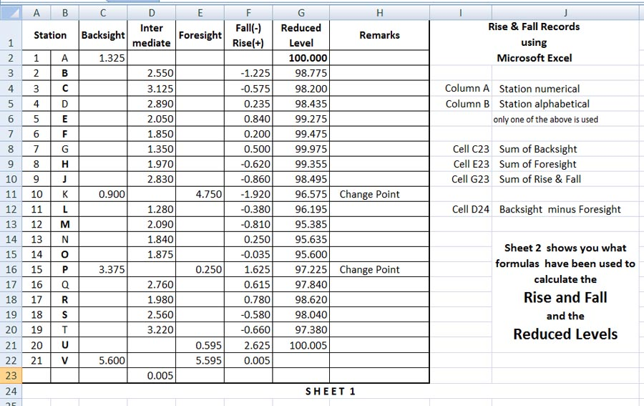
Students lacking computer skills and can't the instruction should contact me.

Remember first activate the cell in which the formula goes then type = and select the data cell and the oprerand (+, -, * or /)
